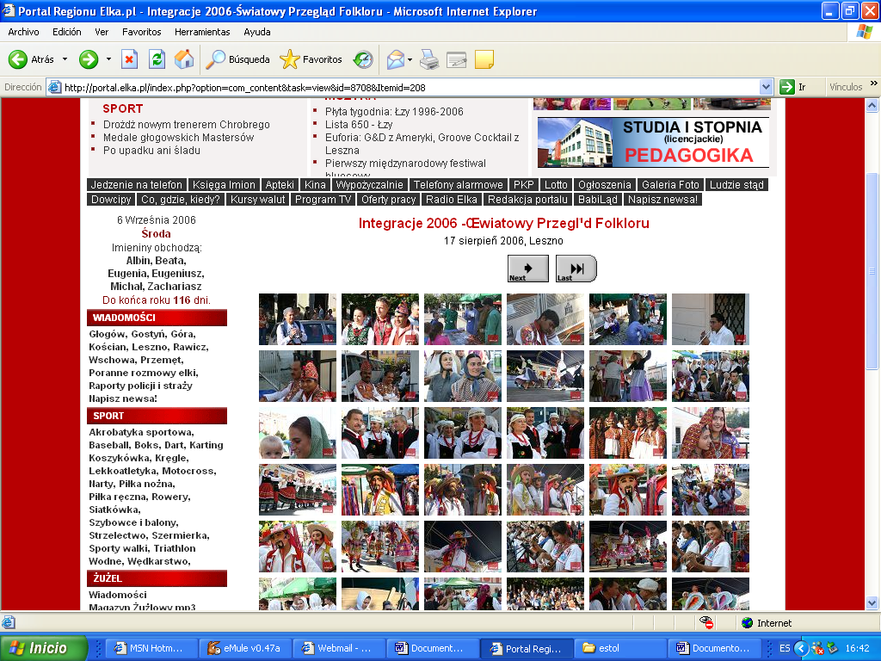

http://portal.elka.pl/index.php?option=com_content&task=view&id=8708&Itemid=208

